High Level Design (HLD)

Analyse Debt Statistics

Revision No: 1.0

Last Date of Revision: 25 Sep 2024

Swapnanil Mandal

**Document Version Control**

|  |  |  |  |
| --- | --- | --- | --- |
| Date Issued | Version | Description | Author |
| 24/09/2024 | 1.0 | First Version of Complete HLD | Swapnanil Mandal |
|  |  |  |  |
|  |  |  |  |
|  |  |  |  |
|  |  |  |  |
|  |  |  |  |
|  |  |  |  |

**Contents**

**Document Version Control**

**Abstract**

1. **Introduction**

1.1 Why this High-Level Design Document?

* 1. Scope

1. **General Description**

2.1 Problem Statement

* 1. Tools Used

1. **Design Details**

3.1 Functional Architecture

**4. Visualizations**

4.1 Key Indicators

**5. Deployment**...................................................................................................................................

**Abstract**

It's not that we humans only take debts to manage our necessities. A country may also take debt to manage its economy. For example, infrastructure spending is one costly ingredient required for a country's citizens to lead comfortable lives. The World Bank is the organization that provides debt to countries.

We are going to analyze international debt data collected by The World Bank. The dataset contains information about the amount of debt (in USD) owed by developing countries across several categories.

1. **Introduction**
   1. **Why this High-Lovel Design Document?**

The purpose of this High-Level Design (HLD) Document is to add the necessary detail to the current project description to represent a suitable model for coding. This document is also intended to help detect contradictions prior to coding and can be used as a reference manual for how the modules interact at a high level.

The HLD will:

* Present all the design aspects and define them in detail.
* Describe the user interface being implemented.
* Describe the hardware and software interfaces.
* Describe the performance requirements.
* Include design features and the architecture of the project.
* List and describe the non-functional attributes like:
* Security Reliability
* Maintainability
* Portability
* Reusability
* Application compatibility
* Resource utilization
* Serviceability

**1.2 Scope**

The HLD documentation presents the structure of the system, such as the database architecture, application architecture (layers), application flow (Navigation), and technology architecture. The HLD uses non-technical to mildly technical terms which should be understandable to the administrators of the system.

**2. General Description**

**2.1 Product Perspective & Problem Statement**

It's not that we humans only take debts to manage our necessities. A country may also take debt to manage its economy. For example, infrastructure spending is one costly ingredient required for a country's citizens to lead comfortable lives. The World Bank is the organization that provides debt to countries.

The objective of the project is to perform data visualization techniques to understand the insight of the data. This project aims apply Business Intelligence tool Power BI to get a visual understanding of the data.

**2.2 Tools used**

Business Intelligence tool such as Power BI are used to build the whole framework.

**3. Design Details**

**3.1 Functional Architecture**

Figure 1: Functional Architecture of Business Intelligence

How BI Really Works

Presentation

Information Integration

Insight Creation

Organisational Memory

**4. Visualizations**

Visualizations (known as visuals for short) display insights that have been discovered in the data. A Power BI report might have a single page with one visual, or it might have pages full of visuals. In the Power BI service, visuals can be pinned from reports to dashboards.

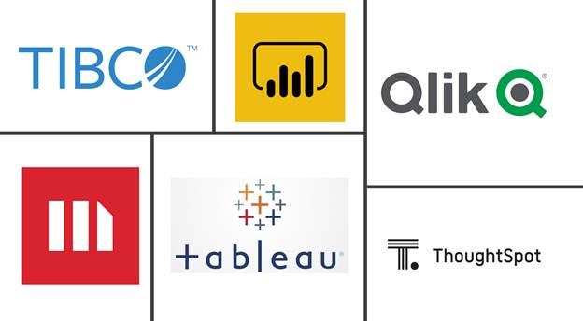

Key indicators displaying a summary of the Housing Price and its relationship metrics

1. The World Bank's international debt data.

2. Finding the number of distinct countries.

3. Finding out the distinct debt indicators.

4. Totaling the amount of debt owed by the countries.

5. Country with the highest debt.

6. Average amount of debt across indicators.

7. The highest amount of principal repayments.

8. The most common debt indicator.

9. Other viable debt issues and conclusion.

**5. Deployment**

Prioritizing data and analytics couldn't come at a better time. Your company, no matter what size, is already collecting data and most likely analyzing just a portion of it to solve business problems, gain competitive advantages, and drive enterprise transformation. With the explosive growth of enterprise data, database technologies, and the high demand for analytical skills, today's most effective IT organizations have shifted their focus to enabling self-service by deploying and operating Power BI at scale, as well as organizing, orchestrating. and unifying disparate sources of data for business users and experts alike to author and consume content.

In today’s world, analytics is a vital part of decision making in almost every organization. The growing use of Power BI as an analytics tool, requires it to use more data, look appealing and be user-friendly. Above all however, Power BI needs to always be available and reliable. To meet these requirements, BI creators must collaborate effectively.

The deployment pipelines tool enables BI creators to manage the lifecycle of organizational content. It's an efficient and reusable tool for creators in an enterprise with Premium capacity. Deployment pipelines enable creators to develop and test Power BI content in the Power BI service, before the content is consumed by users. The content types include reports, paginated reports, dashboards, datasets, and dataflows.

The tool is designed as a pipeline with three stages:

* Development

This stage is used to design, build, and upload new content with fellow creators. This is the first stage in deployment pipelines.

* Test

You're ready to enter the test stage after you've made all the needed changes to your content. You upload the modified content so it can be moved to this test stage. Here are three examples of what can be done in the test environment:

* 1. Share content with testers and reviewers.
  2. Load and run tests with larger volumes of data.
  3. Test your app to see how it will look for your end users.
* Production

After testing the content, use the production stage to share the final version of your content with business users across the organization.

